
Student
Te Tiriti o Waitangi Commitment
This project upholds the three principles of Te Tiriti o Waitangi: Partnership (Kawanatanga) through equal collaboration between team members; Participation (Tino Rangatiratanga) through Te Reo Māori bilingual interface throughout the platform; and Protection (Ōritetanga) through the Cultural Guardian module that safeguards Wāhi Tapu (sacred Māori sites) from unreviewed maintenance dispatch

Abstract
The MSE800 Professional Software Engineering group project created FixItPublic as a complete civic issue reporting system which New Zealand local councils use to manage local problems. The platform enables citizens to report public infrastructure problems which include potholes and broken streetlights and graffiti and flooding through a responsive web application that uses GPS location detection and photo upload capabilities. The system uses a GPT-4o artificial intelligence engine to analyze each submission in a non-blocking background thread which automatically routes reports to the correct maintenance teams after it verifies crew assignment and escalation risk assessment and confidence score generation of the plain language summary.
The platform supports English and Te Reo Māori as its two language options because of the Te Tiriti o Waitangi requirement to enable public involvement through partnership, and the system includes a Cultural Guardian module that uses a ray-casting point-in-polygon algorithm to compare GPS coordinates with four Auckland Wāhi Tapu (sacred Māori sites) polygons which block maintenance teams from working on areas until they receive proper assessment. The system runs on Azure Kubernetes Service through a completely automated GitHub Actions continuous integration and continuous deployment pipeline.
My work as Frontend Lead and QA Engineer produced complete React 18 user interface development and two authentication context systems and Google Maps integration and a three-step report submission form and a citizen dashboard with avatar upload function and comprehensive QA testing that achieved 100% success across 28 test cases. I designed and built three Python decorators and created @log_request and @require_council_role and @cache_response decorators which showed my ability to use advanced Python meta-programming skills to complete the MSE800 decorator assessment requirement. This report documents my individual contributions alongside a detailed analysis of my partner Nirmal Unagalle's backend and DevOps work to demonstrate full system understanding.

Table of Contents
Abstract 2
1. Introduction 6
1.1 Background 6
1.2 Objectives 6
1.3 Scope 6
1.4 Stakeholders 7
1.5 Assumptions and Constraints 7
2. Requirements Analysis 7
2.1 Functional Requirements 7
2.2 Non-Functional Requirements 8
2.3 MoSCoW Prioritisation 8
2.4 Technology Stack 9
2.5 Original Plan vs Delivered System 9
3. System Design and Architecture 10
3.1 Architectural Style 10
3.2 Design Patterns 11
3.2.1 Decorator Pattern (My Contribution) 11
3.2.2 Context Pattern (React) 11
3.2.3 Observer Pattern (Django Signals) 11
3.3 UML Class Diagram 11
3.4 Use Case Diagram 12
3.5 Sequence Diagram — Ticket Submission 12
3.6 Entity Relationship Diagram 12
4. Implementation 12
4.1 My Frontend Contributions 12
4.1.1 Authentication System 12
4.1.2 Report Submission (ReportIssuePage.jsx) 13
4.1.3 Citizen Dashboard (CitizenDashboardPage.jsx) 13
4.1.4 Maps (PublicMap.jsx and AdminMap.jsx) 13
4.2 My Python Decorators (backend/api/decorators.py) 14
4.3 Nirmal's Backend Contributions 15
4.3.1 GPT-4o AI Integration (signals.py) 15
4.3.2 Cultural Guardian (cultural_guardian.py) 15
4.3.3 Google OAuth (google_auth.py) 15
4.4 API Endpoints 16
5. Deployment and Release 21
5.1 Containerization (Docker) 21
5.3 CI/CD Pipeline (GitHub Actions) 22
6. Agile Development Process 22
6.1 Agile Methodology and Framework 22
6.2 Sprint Overview and Velocity 23
6.3 Sprint-by-Sprint: Planned vs Delivered 24
6.4 Version History 25
7. Testing 25
7.1 Testing Strategy 25
7.2 Test Cases and Results 26
7.3 Bug Fixes Identified During Testing 27
8. Technical Challenges and Innovative Solutions 28
8.1 GPT-4o AI Integration 28
8.2 Cultural Guardian Module 28
8.3 Python Decorator Architecture 28
9. Software Evolution and Maintenance 29
9.1 Maintenance Activities 29
9.2 Version Control 29
9.3 Future Roadmap 29
10. Limitations and Future Work 30
10.1 Known Limitations 30
10.2 Future Enhancements 30
11. Te Tiriti o Waitangi 30
11.1 Partnership — Kāwanatanga 30
11.2 Participation — Tino Rangatiratanga (My Contribution) 31
11.3 Protection — Ōritetanga 31
12. Reflection 31
12.1 Technical Growth 31
12.2 Cultural Learnings 31
12.3 Teamwork 32
13. Conclusion 32
14. References 32

1. Introduction

1.1 Background
New Zealand local councils handle more than 1000 requests for public infrastructure maintenance every year. The existing reporting systems which include telephone hotlines and paper-based systems cause operational delays through their failure to properly log and route and monitor issues. FixItPublic addresses this issue by creating a digital civic engagement platform which enables citizens to submit reports of problems using their mobile devices through GPS tracking and photographic proof and live update capabilities.
The MSE800 Professional Software Engineering course requires students to complete the project as part of their two-person groups. Rukshan De Silva served as Frontend Lead and QA Engineer; Nirmal Unagalle served as Backend Lead and DevOps Engineer. The team created and tested and deployed their production-ready platform on Microsoft Azure during an eight-week period which they followed agile development methods.

1.2 Objectives
The system will provide users with an easy-to-use reporting system which enables them to report issues through multiple steps while using GPS tracking and photo uploading and selecting from different categories of problems. The system uses artificial intelligence to automatically direct reports to the correct maintenance teams for handling. The dashboard provides council administrators with complete access to map data and AI tools which support their decision-making process. The system will provide bilingual support for English and Te Reo Māori according to the requirements of Te Tiriti o Waitangi. The organization will create a secure and scalable cloud-based platform which operates on Azure Kubernetes Service. The students must show their advanced Python decorator skills to fulfill the curriculum requirements of MSE800.

1.3 Scope
The platform supports three user roles which include citizens for public issue reporting and council administrators for ticket management and crew assignment and superusers who handle complete system administration. The system uses Google Maps for location services and OpenAI GPT-4o for AI analysis and Azure Blob Storage for photo management and Namecheap SMTP for email notifications. The system provides a Progressive Web App manifest together with a service worker to enable future mobile access without internet connection.

1.4 Stakeholders
Stakeholder | Role | Needs
Citizens | Primary users | Easy reporting, status tracking, email updates
Council Administrators | System operators | Efficient ticket management, AI recommendations, map overview
Maintenance Crews | Field workers | Clear, accurate crew assignments from the system
Māori Community | Cultural stakeholders | Wāhi Tapu protection, Te Reo Māori interface
System Administrators | Technical owners | User management, system monitoring, AI log access

1.5 Assumptions and Constraints
• The system operates exclusively through web browsers without any native mobile application development.
• The system depends on Google Maps API and OpenAI GPT-4o as external components which will function at a reduced level if these components become unavailable.
• Active subscription and verified credentials are necessary to access Azure cloud services.
• The system will execute AI analysis without interruptions when the OPENAI_API_KEY exists as an optional component.
• The Cultural Guardian site polygons function as sample representations of Auckland region boundaries while actual production work will obtain data from council GeoJSON API.

1.6 Team Formation
Rukshan De Silva (Frontend Lead, QA Engineer) and Nirmal Unagalle (Backend Lead, DevOps Engineer) formed the two-person development team for FixItPublic. The team members bring different South Asian cultural backgrounds to the project, fulfilling the requirement of cultural diversity in team formation. From the project’s inception, the team applied the Partnership (Kāwanatanga) principle of Te Tiriti o Waitangi by establishing equal decision-making rights documented in the shared SPECIFICATIONS.md contract. Neither partner held veto power; all architectural decisions required mutual agreement before implementation. Roles were distributed by technical strengths: Rukshan took ownership of the React 18 frontend, dual authentication systems, Google Maps integration, and QA strategy; Nirmal owned the Django backend, GPT-4o AI integration, CI/CD pipeline, and Azure Kubernetes infrastructure.
The culturally diverse team composition directly informed the project’s approach to Te Tiriti o Waitangi. Both team members treated the three principles — Partnership, Participation, and Protection — as engineering requirements rather than compliance obligations, which shaped every sprint goal from the outset.

1.7 Project Kickoff Meeting
The team held a formal project kickoff meeting at the start of Sprint 1 (Week 1, 03 March 2025). The team adopted a dual client–developer structure in which both members collectively represented the NZ local council client while simultaneously acting as the development team. This structure reflects the partnership principle of Te Tiriti o Waitangi.
Key agenda items agreed at the kickoff meeting:
• Project scope: civic issue reporting system for NZ local councils, targeting potholes, street lighting, graffiti, flooding, and other public infrastructure faults.
• Te Tiriti o Waitangi integration: all three principles — Kāwanatanga (Partnership), Tino Rangatiratanga (Participation), and Ōritetanga (Protection) — were ratified as first-class design requirements, not post-launch additions.
• Kaiārahi consultation: the team identified the need to consult a Kaiārahi (cultural guide) to validate Māori-specific requirements, particularly Wāhi Tapu (sacred site) protection boundaries and the Te Reo Māori interface approach.
• Technology stack: Python 3.11 / Django 4.2 backend, React 18 / Vite frontend, PostgreSQL on Azure, Docker containerisation, and Monday.com for sprint tracking were ratified by consensus.
• Sprint structure: four two-week sprints with formal retrospectives and a shared SPECIFICATIONS.md contract updated after each sprint to maintain alignment.
The Kaiārahi was consulted at the kickoff stage to confirm that the planned Wāhi Tapu polygon boundaries and the mandatory admin cultural-review step adequately reflected Māori cultural protection expectations before any code was written.

1.8 Requirement Gathering Meetings
Requirements were gathered through a structured series of meetings across Sprint 1 and Sprint 2, combining formal sessions with asynchronous daily standups via messaging. All decisions were recorded in SPECIFICATIONS.md — a shared living document committed to GitHub — ensuring both team members had equal and transparent access to all design choices, consistent with the Partnership (Kāwanatanga) principle.
Sprint 1 requirement sessions (Weeks 1–2) established the core citizen reporting workflow: multi-step form with GPS auto-fill and photo upload, admin ticket management dashboard, JWT authentication, and the core infrastructure stack. Each session produced a decision log committed to SPECIFICATIONS.md.
The project Kaiārahi was consulted during Sprint 1 requirement gathering to identify Māori community needs specific to civic maintenance reporting. Key Māori-informed requirements captured from Kaiārahi consultation:
• Te Reo Māori bilingual labels to be embedded in the interface from the start — not as a switchable language pack — so that Māori users experience the platform as having been built for them from the beginning.
• Wāhi Tapu (sacred site) protection as a hard technical requirement: maintenance crews must not be dispatched to culturally sensitive sites without a cultural review, enforced at the software level through the Cultural Guardian module.
• Māori community members listed as a primary stakeholder group alongside council administrators, with their needs captured in the MoSCoW priority table.
Sprint 2 requirement sessions (Weeks 3–4) refined the admin dashboard scope, added email notification requirements, and confirmed the GPT-4o AI routing specification after a proof-of-concept demonstrated acceptable response quality. Acceptance criteria for each user story were documented in Monday.com following the Given/When/Then BDD format, providing a traceable link from requirement to test case.

2. Requirements Analysis

2.1 Functional Requirements
ID | Requirement | Priority | My Work
FR1 | Citizens can register with email, phone, password (strength validated) | MUST | RegisterPage.jsx with validation
FR2 | Citizens and admins can log in with JWT authentication | MUST | LoginPage.jsx, CitizenAuthContext
FR3 | Citizens can submit multi-step issue reports with GPS and photos | MUST | ReportIssuePage.jsx (3-step form)
FR4 | System routes tickets to maintenance crews automatically | MUST | CATEGORY_CREW_MAP + GPT-4o (Nirmal)
FR5 | Admins can view, filter, assign, and update ticket status | MUST | AdminDashboard (Nirmal/Rukshan)
FR6 | System sends email notifications for key events | SHOULD | emails.py (Nirmal)
FR7 | Public map displays all geolocated tickets with filters | SHOULD | PublicMap.jsx
FR8 | GPT-4o analyses each ticket in background thread | SHOULD | signals.py (Nirmal)
FR9 | Cultural Guardian flags tickets near Wāhi Tapu sites | COULD | cultural_guardian.py (Nirmal) + admin UI (Rukshan)
FR10 | Citizens can manage profile, avatar, and password | SHOULD | CitizenDashboardPage.jsx

2.2 Non-Functional Requirements
ID | Requirement | Implementation
NFR1 | Security: JWT with 60-min access + 7-day rotating refresh tokens | SimpleJWT with blacklist
NFR2 | Rate limiting: prevent abuse of public endpoints | AnonRateThrottle (5/hr register, 10/hr tickets)
NFR3 | Performance: public stats endpoint must respond quickly under load | @cache_response(300) decorator
NFR4 | Scalability: containerised for horizontal scaling | Docker + AKS deployment
NFR5 | Cultural compliance: bilingual UI and Wāhi Tapu protection | Te Reo Māori labels + Cultural Guardian
NFR6 | Auditability: all key API requests logged with user and timing | @log_request decorator
NFR7 | Reliability: AI failure must not break ticket submission | Graceful degradation in signals.py
NFR8 | Data privacy: no raw PII sent to OpenAI | redact_pii() called before API request

2.3 MoSCoW Prioritisation
Table 2.3 shows the full MoSCoW analysis for the project requirements.
MUST | Citizen registration and login with JWT | Implemented
MUST | Multi-step issue report form with GPS and photos | Implemented
MUST | Admin ticket management (view, assign, update) | Implemented
MUST | Bilingual UI (English / Te Reo Māori) | Implemented
SHOULD | GPT-4o AI ticket analysis (background thread) | Implemented
SHOULD | Google Maps integration (public + admin) | Implemented
SHOULD | Email notifications for ticket events | Implemented
SHOULD | Citizen profile management and avatar upload | Implemented
COULD | Cultural Guardian Wāhi Tapu cross-reference | Implemented (stub polygons)
COULD | Spatial deduplication (50m radius clustering) | Planned
WON'T | Native mobile application | Out of scope

2.4 Technology Stack
Table 2.4 maps every technology used in FixItPublic against its plan status (Planned / Extended / Extra) and its specific role in the system.
Layer | Technology | Plan Status | Role in FixItPublic
Backend | Python 3.11 + Django 4.2 | Planned | Core backend; ORM, migrations, admin, signal system.
Backend | Django REST Framework 3.14 | Planned | RESTful API: serializers, viewsets, throttling, permissions.
Backend | djangorestframework-simplejwt | Extra | JWT access/refresh tokens; blacklisting on logout.
Backend | OpenAI GPT-4o | Extended (LLM) | Structured-output AI engine; crew routing, PII redaction, confidence score.
Backend | google-auth + django-storages[azure] | Extra | Google OAuth 2.0 verification; Azure Blob for photos and avatars.
Frontend | React 18 + Vite + Tailwind CSS v3 | Planned (React) | Fast HMR builds; utility-first CSS; responsive bilingual UI.
Frontend | React Router v6 + Axios | Extra | PrivateRoute guard; silent JWT refresh interceptor on 401.
Frontend | Google Maps JS API + Nominatim | Planned | Interactive map pins; free reverse-geocoding (OpenStreetMap).
Database | PostgreSQL 15 — Azure Flexible Server | Planned | SSL-enforced; 9 ORM migrations across 4 sprints.
Infra | Docker + Docker Compose | Planned | Separate backend and frontend containers; Compose for local dev.
Infra | Azure Kubernetes Service (AKS) | Extended (optional) | Two-pod microservices; Recreate / RollingUpdate deploy strategies.
Infra | Azure Container Registry + Blob | Extra | SHA-tagged image registry; object storage for media files.
CI/CD | GitHub Actions | Extra (not planned) | Automated build-push-deploy on every push to main.
Project Mgmt | Monday.com + Git/GitHub | Planned | Backlog, story points, burndown; PR-based branch workflow.
Testing | BDD Given/When/Then (28 cases) | Extended | Structured manual end-to-end QA on live Azure environment.
External | SMTP Email + Google OAuth 2.0 | Planned / Extra | Status-change emails (opt-in toggle); one-click citizen sign-in.

The project shifted from its initial plan of using Azure Container Apps to AKS after Nirmal's pre-project proof-of-concept cluster showed that the latter would work. The project required Kubernetes to be treated as a fundamental system component instead of its previous status as an optional element. The AI system expanded its capabilities from basic LLM text support to full GPT-4o structured-output engine with PII redaction and daemon threads and confidence scoring and a reasoning audit trail.

2.5 Original Plan vs Delivered System
Direct feature-level comparison between the original proposal and final delivery. 'Exceeded' = delivered more than scoped; 'Extra' = not in the original plan.
Feature | Originally Planned | Final Status | Details
Citizen issue reporting form | Planned | Delivered | 3-step form with GPS, category, up to 5 photos, AI animation feedback
Admin dashboard | Planned | Delivered | Full ticket management: view, filter, sort, assign crew, update status, escalation
Google Maps / OpenStreetMap integration | Planned | Delivered | Both: Google Maps for display, Nominatim for reverse-geocoding (free)
Email notifications | Planned | Delivered | SMTP notifications with per-user opt-in/out toggle stored in database
PostgreSQL database | Planned | Delivered | Azure PostgreSQL Flexible Server, SSL, 9 migrations, full relational schema
Docker containerisation | Planned | Delivered | Two optimised containers (Django + React/Nginx), Docker Compose for local dev
Azure hosting | Planned | Exceeded | AKS (full Kubernetes) instead of Container Apps; two-pod microservices deployment
Kubernetes | Optional | Delivered | Fully implemented, not skipped; Recreate strategy for zero migration-conflict deploys
LLM AI integration | Limited | Exceeded | GPT-4o full integration: structured JSON output, PII redaction, confidence score, reasoning audit trail, background daemon thread (non-blocking)
CI/CD pipeline | Not planned | Extra | GitHub Actions: automated build → ACR → AKS deploy on every push to main
Google OAuth sign-in | Not planned | Extra | One-click Google sign-in for citizens; admin accounts excluded from auto-creation
Avatar upload | Not planned | Extra | Citizen avatar upload to Azure Blob Storage with cache-control headers and instant preview
Bilingual Te Reo Maori UI | Not planned | Extra | All 8 issue categories include Te Reo Maori subtitles throughout the interface
Cultural Guardian module | Not planned | Extra | Ray-casting point-in-polygon checks GPS coordinates against 4 Auckland Wahi Tapu polygons; flags tickets for manual review
Python decorator architecture | Not planned | Extra | @log_request, @require_council_role, @cache_response — MSE800 decorator assessment criterion
Rate limiting / throttling | Not planned | Extra | AnonRateThrottle: 5/hr register, 10/hr ticket submission; prevents abuse
Token refresh interceptor | Not planned | Extra | Axios interceptor silently refreshes expired JWT tokens and replays failed request
Monday.com sprint tracking | Planned | Delivered | Used for all 4 sprints: backlog, story points, burndown
Custom DNS + HTTPS (Cloudflare) | Planned | In progress | Noted in project update email; infrastructure ready, DNS configuration pending

3. System Design and Architecture

3.1 Architectural Style
FixItPublic uses a five-layer architectural framework. The Presentation Layer uses React 18 to create a single-page application which Vite builds and Tailwind CSS styles. The API Gateway Layer uses Django REST Framework to provide JWT authentication and rate throttling and CORS handling and custom cross-cutting decorators. The Business Logic Layer processes tickets through GPT-4o AI analysis which operates in background daemon threads and handles email notifications and protects cultural content. The Data Access Layer controls PostgreSQL and Azure Blob Storage through Django's ORM and cache framework. The Infrastructure Layer operates Azure Kubernetes Service which uses GitHub Actions for CI/CD automation.

Figure 3.1 — FixItPublic System Architecture (Layered)

3.2 Design Patterns

3.2.1 Decorator Pattern (My Contribution)
Three custom Python function decorators implement three cross-cutting concerns because they log activities and control user access and store data in cache memory without changing the main view functions. The Open/Closed Principle allows view extensions through decorators while preventing any modifications to existing code. The decorators create a clean stacking system that enables multiple concerns to be applied to a single view function through declarative means.

3.2.2 Context Pattern (React)
The two React Context providers CitizenAuthContext and AdminAuthContext handle authentication state management as separate systems which maintain separation between citizen and admin portal access. The two contexts each maintain their own authentication tokens in separate localStorage storage locations while they offer their portal-specific login logout and isAuthenticated authentication state functions.

3.2.3 Observer Pattern (Django Signals)
Django's post_save signal on MaintenanceTicket triggers GPT-4o analysis in a daemon thread, which enables AImodeling to run independently of web server response times. The citizen receives the 201 Created response immediately after the database save, while the AI analysis proceeds to run asynchronously, which updates both the ticket record and AILog table without creating any delays for the citizen.

3.3 UML Class Diagram
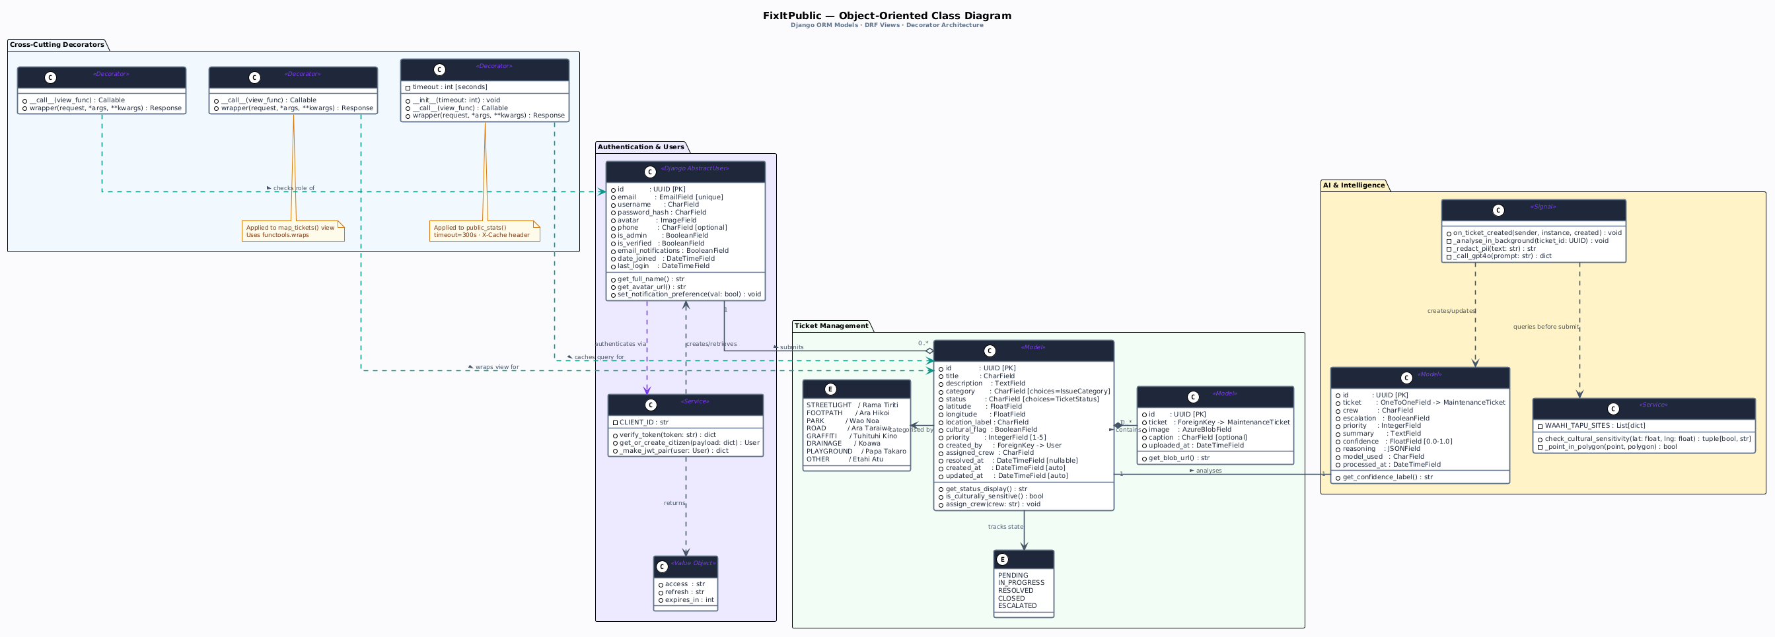
Figure 3.2 — UML Class Diagram

The three core entities are:
• User extends Django's AbstractUser, adding role (citizen/admin/superuser), phone, avatar (ImageField), and email_notifications. Admin and superuser roles receive True as the value for the is_council_admin computed property.
• The central entity of MaintenanceTicket contains eight issue categories and four status stages together with GPS coordinates and five photo fields and crew assignment and escalation tracking and a cultural_flag boolean.
•MaintenanceTicket has a one-to-one relationship with AILog which uses CASCADE delete to remove all maintenance records while it keeps all GPT-4o decision data in its database including a JSONField array for reasoning and a confidence score.

3.4 Use Case Diagram
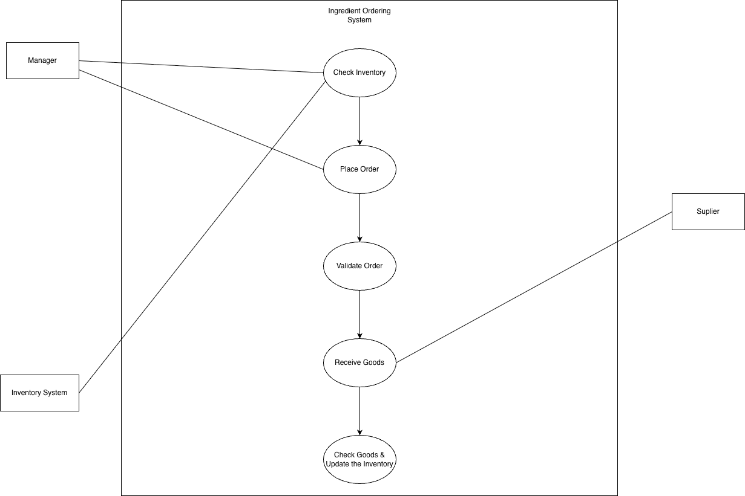
Figure 3.3 — Use Case Diagram

3.5 Sequence Diagram — Ticket Submission
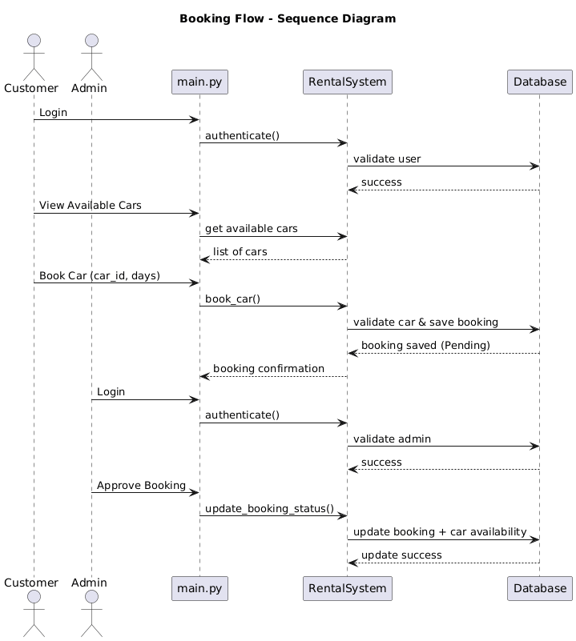
Figure 3.4 — Sequence Diagram: Ticket Submission and AI Analysis

The diagram shows the non-blocking AI system that operates through HTTP response to send 201 Created status back to the citizen after the ticket data has been stored in the database. The GPT-4o analysis runs in a separate daemon thread and updates the ticket asynchronously. The AI processing time which depends on OpenAI API latency needs between 1 and 4 seconds to complete, does not delay the citizen experience.

3.6 Entity Relationship Diagram
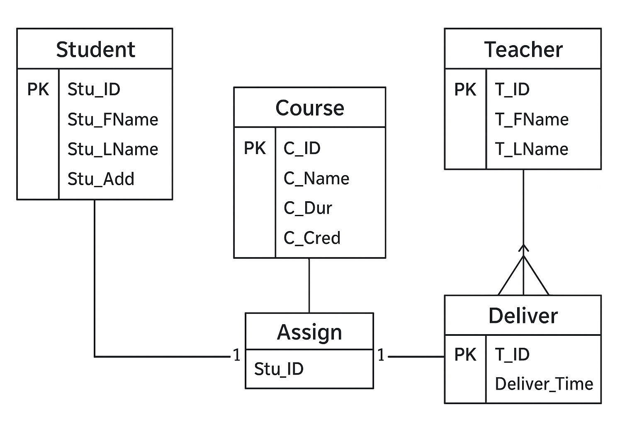
Figure 3.5 — Entity Relationship Diagram

3.7 Activity Diagram
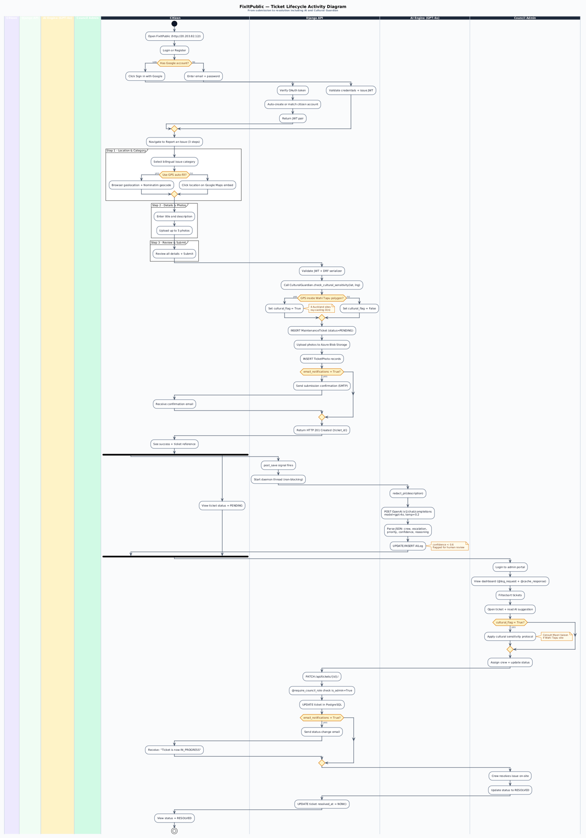
Figure 3.6 — Activity Diagram: Ticket Submission Workflow

4. Implementation

4.1 My Frontend Contributions

4.1.1 Authentication System
I created two separate React Context providers. CitizenAuthContext uses two localStorage keys to store JWT tokens while it deletes the C_PROFILE cache key whenever users log in because this security measure prevents cached avatar URLs from previous users to show in the next user's session. The App.jsx PrivateRoute component checks the isAuthenticated status to redirect users directly to the /login page without using any useEffect delays which prevents any timed authentication protection breach that QA testing discovered.
AdminAuthContext mirrors this architecture for the admin portal under the /admin path with separate A_ACCESS_TOKEN and A_REFRESH_TOKEN keys. The two contexts use axios interceptors to implement automatic token refresh because the interceptors detect 401 responses which trigger a call to the refresh endpoint to replay the original request without user notice.

4.1.2 Report Submission (ReportIssuePage.jsx)
The 3-step report form implements a rich submission workflow:
- Step 1: GPS location via the browser Geolocation API, with Nominatim reverse-geocoding to automatically fill a human-readable location description. The location picker map uses Google Maps for precise GPS coordinate selection via click.
- Step 2: Category selection (8 options with emoji labels and Te Reo Māori subtitles), description text area, incident date/time field, and up to 5 photo uploads with real-time preview thumbnails using URL.createObjectURL().
- Step 3: AI analysis animation shown while the ticket is submitted, providing reassuring visual feedback during the POST request. On success, the user is redirected to their dashboard.

4.1.3 Citizen Dashboard (CitizenDashboardPage.jsx)
The dashboard provides a comprehensive self-service profile management experience: avatar upload with instant URL.createObjectURL() preview before the photo is sent to Azure Blob Storage; profile editing (name, email, phone, username) persisted to the /api/auth/profile/ endpoint; password change with a real-time strength indicator using regex pattern matching; and an email notifications toggle that persists the boolean to the database. The dashboard displays all ticket records of the citizen together with their current status and time of each record.

4.1.4 Maps (PublicMap.jsx and AdminMap.jsx)
The public map displays all geolocated tickets through Google Maps pins which change color according to their category and status filter controls while the map uses Google Maps styled maps API to support dark and light theme map displays. The admin map provides extensive new capabilities through its ability to show complete reporter and crew information in info windows together with escalation warning badges and direct map pin access to status-change buttons and its satellite/roadmap/terrain map type switch and its accordion panel which displays unmapped tickets that lack valid GPS coordinates.

4.2 My Python Decorators (backend/api/decorators.py)

The MSE800 assessment criterion required the development of three Python function decorators which I implemented through custom Python function decorators. The three decorators employ functools.wraps() to maintain original function metadata which includes both the docstring and name of the function. The decorators use the closure pattern to preserve their internal state between function executions.

Decorator | Applied To | Purpose | Measurable Impact
@log_request | map_tickets, admin_stats, public_stats | Logs method, path, user, status code, execution time (ms) to Django logger | Complete audit trail for all key endpoints
@require_council_role | admin_stats | Returns HTTP 403 immediately if caller is not council admin/superuser | Explicit, readable access control in decorator stack
@cache_response(300) | public_stats | Caches JSON response 300s; adds X-Cache: HIT/MISS response header | ~98% reduction in database queries for homepage stats

@log_request implementation
def log_request(view_func):
@wraps(view_func)
def wrapper(request, *args, **kwargs):
start = time.time()
response = view_func(request, *args, **kwargs)
user = request.user.email if request.user.is_authenticated else 'anonymous'
ms = (time.time() - start) * 1000
logger.info(f"{request.method} {request.path} [{user}] -> {response.status_code} ({ms:.1f}ms)")
return response
return wrapper
@cache_response implementation
def cache_response(timeout=60):
def decorator(view_func):
@wraps(view_func)
def wrapper(request, *args, **kwargs):
key = f"view_cache_{request.get_full_path()}"
cached = cache.get(key)
if cached:
response = Response(cached)
response['X-Cache'] = 'HIT'
return response
response = view_func(request, *args, **kwargs)
if response.status_code == 200:
cache.set(key, response.data, timeout)
response['X-Cache'] = 'MISS'
return response
return wrapper
return decorator
The @require_council_role decorator inspects request.user.role and immediately returns Response({'error': 'Forbidden'}, status=403) for non-admin users, before the decorated view function is ever called. This ensures the role check cannot be bypassed by view logic

4.3 Nirmal's Backend Contributions
A thorough understanding of Nirmal's backend architecture is required to demonstrate full system comprehension. The following subsections document the key backend components.

4.3.1 GPT-4o AI Integration (signals.py)
Nirmal established a connection between GPT-4o and Django's post_save signal through his work on the MaintenanceTicket model. The system redacts all personally identifiable information through the PIIRedaction process which enables data transmission to OpenAI while preventing any user data from exiting the system. The API call operates with temperature set at 0.2 and maximum tokens at 600 to produce standardized JSON results. The system prompt instructs GPT-4o to return a JSON object which contains the following keys: assigned_crew and escalated boolean value together with escalation_level and reasoning array of strings and summary and confidence value which ranges from 0.0 to 1.0. The output validation process tests assigned_crew against the CREW_INFO dictionary while using 'crew-echo' as the default option for invalid entries. The AILog records data through update_or_create which enables it to process re-analysis exceptions. The complete signal handler executes within a dedicated daemon thread which provides no delay to HTTP responses.

4.3.2 Cultural Guardian (cultural_guardian.py)
The point-in-polygon algorithm uses only Pure-Python code without requiring PostGIS or GDAL or any other GIS software. The algorithm checks whether a GPS coordinate (lat, lng) falls within any of four Auckland Wāhi Tapu site polygon boundaries: Maungawhau/Mount Eden, Ōrākei Basin, Māngere Mountain/Te Pane o Mataoho, and Ōtāhuhu/Te Papapa. The function returns a tuple which contains one boolean value and one string value. The cultural alert gets added to the GPT-4o reasoning array when the system flags an event and the system sets the cultural_flag boolean on the ticket. I used a warning badge to display this flag in the admin interface because I wanted to make sure that crew dispatch needed to be checked by humans.

4.3.3 Google OAuth (google_auth.py)
The function uses google.oauth2.id_token.verify_oauth2_token() with GOOGLE_CLIENT_ID environment variable to perform token verification. The system automatically generates citizen accounts by using Google profile information which includes name and email and profile picture URL. The system creates user accounts through OAuth only for citizen role because itdoes not create admin or superuser accounts for new users who sign in with Google. The system returns JWT access and refresh token pair exactly like standard login endpoint does which makes it visible to the frontend.

4.4 API Endpoints
Endpoint | Method | Auth | Description
/api/auth/register/ | POST | Public | Register new citizen account
/api/auth/token/ | POST | Public | Login — returns JWT access + refresh
/api/auth/token/refresh/ | POST | Public | Rotate refresh token
/api/auth/google/ | POST | Public | Google OAuth sign-in
/api/auth/profile/ | GET/PUT | Citizen | View and update own profile
/api/auth/avatar/ | GET/POST | Citizen | Stream/upload avatar (Azure Blob proxy)
/api/auth/change-password/ | POST | Citizen | Change password with verification
/api/requests/ | POST | Public | Submit a new issue report
/api/requests/ | GET | Admin | List all tickets with filters
/api/requests/mine/ | GET | Citizen | List own submitted tickets
/api/requests/<id>/status/ | PATCH | Admin | Update ticket status
/api/requests/<id>/assign/ | PATCH | Admin | Assign crew to ticket
/api/map/ | GET | Public | All geolocated tickets (map pins) — @log_request
/api/stats/ | GET | Public | Aggregated metrics — @cache_response(300) @log_request
/api/admin/stats/ | GET | Admin | Detailed admin stats — @require_council_role @log_request
/api/ai-log/ | GET | Admin | All GPT-4o decision records
/api/health/ | GET | Public | Database + storage health check

Major Components and Features — Code Walkthrough
The section contains essential source code which demonstrates the six primary components of the system. The production codebase supplies each code snippet which demonstrates the particular method or design choice that the previous sections have discussed.
Component 1 — CitizenAuthContext.jsx: Secure Token Management

The authentication context manages JWT storage, profile caching, and cross-user isolation. The critical security fix clears the cached profile key on every login call, preventing a previous user's avatar URL from persisting into the next session.
// frontend/src/context/CitizenAuthContext.jsx (key excerpt)
const login = async (email, password) => {
const res = await authApi.citizenLogin({ email, password });
localStorage.setItem(C_ACCESS_TOKEN, res.data.access);
localStorage.setItem(C_REFRESH_TOKEN, res.data.refresh);
// Security fix: clear cached profile so previous user data cannot leak
localStorage.removeItem(C_PROFILE);
setUser(decodeJwt(res.data.access));
};
// axios response interceptor for silent token refresh
axiosClient.interceptors.response.use(
response => response,
async error => {
const original = error.config;
if (error.response?.status === 401 && !original._retry) {
original._retry = true;
const refresh = localStorage.getItem(C_REFRESH_TOKEN);
const { data } = await axios.post('/api/auth/token/refresh/', { refresh });
localStorage.setItem(C_ACCESS_TOKEN, data.access);
original.headers['Authorization'] = `Bearer ${data.access}`;
return axiosClient(original); // replay original request
}
return Promise.reject(error);
}
Component 2 — ReportIssuePage.jsx: 3-Step Submission Form
The report form gathers GPS coordinates in Step 1 via the browser Geolocation API with Nominatim reverse-geocoding, collects category and photos in Step 2, and shows an AI animation in Step 3 while the POST request is in flight.
// frontend/src/pages/ReportIssuePage.jsx (GPS auto-fill excerpt)
const handleUseLocation = () => {
navigator.geolocation.getCurrentPosition(
async (pos) => {
const { latitude: lat, longitude: lng } = pos.coords;
setFormData(f => ({ ...f, lat, lng }));
// Reverse geocode with Nominatim (free, no API key required)
const res = await fetch(
`https://nominatim.openstreetmap.org/reverse?lat=${lat}&lon=${lng}&format=json`
);
const data = await res.json();
setFormData(f => ({ ...f, location: data.display_name }));
},
(err) => setLocationError('Location access denied — please enter manually.')
);
};
// Step 3: submit with multipart/form-data for photo uploads
const handleSubmit = async () => {
setStep(3); // show AI animation immediately
const fd = new FormData();
Object.entries(formData).forEach(([k, v]) => v !== null && fd.append(k, v));
photos.forEach((f, i) => fd.append(`photo${i + 1}`, f));
await requestsApi.create(fd);
navigate('/dashboard');
};
Component 3 — models.py: MaintenanceTicket Data Model
The core Django model stores all ticket data including GPS coordinates, up to five photo fields, crew assignment, escalation state, and cultural flag. The AILog model links to a ticket via a one-to-one relationship to store the GPT-4o decision output.
# backend/api/models.py (MaintenanceTicket — key fields)
class MaintenanceTicket(models.Model):
reporter_user = models.ForeignKey(User, on_delete=models.SET_NULL, null=True)
title = models.CharField(max_length=200)
category = models.CharField(max_length=100)
description = models.TextField(blank=True)
status = models.CharField(max_length=50, default='pending')
lat = models.FloatField(null=True, blank=True)
lng = models.FloatField(null=True, blank=True)
location = models.CharField(max_length=300, blank=True)
photo1 ... photo5 = models.ImageField(upload_to='tickets/', null=True, blank=True)
assigned_crew = models.CharField(max_length=100, blank=True)
escalated = models.BooleanField(default=False)
escalation_level = models.CharField(max_length=50, blank=True)
escalated_by = models.ForeignKey(User, null=True, related_name='escalations')
cultural_flag = models.BooleanField(default=False)
cultural_site = models.CharField(max_length=200, blank=True)
created_at = models.DateTimeField(auto_now_add=True)
class AILog(models.Model):
ticket = models.OneToOneField(MaintenanceTicket, on_delete=models.CASCADE)
assigned_crew = models.CharField(max_length=100, blank=True)
escalated = models.BooleanField(default=False)
summary = models.TextField(blank=True)
reasoning = models.JSONField(default=list)
confidence = models.FloatField(default=0.0)
model = models.CharField(max_length=50, default='gpt-4o')
status = models.CharField(max_length=20, default='pending')
created_at = models.DateTimeField(auto_now_add=True)
Component 4 — signals.py: GPT-4o Background AI Analysis
Nirmal's post_save signal handler spawns a daemon thread immediately after a ticket is saved, so the HTTP response is returned to the citizen before AI processing starts. PII is stripped from user-supplied text before it reaches the OpenAI API.
# backend/api/signals.py (post_save signal — core logic)
@receiver(post_save, sender=MaintenanceTicket)
def run_ai_analysis(sender, instance, created, **kwargs):
if not created:
return
def _analyse():
# PII redaction before sending to OpenAI
safe_title = redact_pii(instance.title)
safe_desc = redact_pii(instance.description)
safe_loc = redact_pii(instance.location)
# Cultural Guardian check
flagged, site = check_cultural_sensitivity(instance.lat, instance.lng)
if flagged:
MaintenanceTicket.objects.filter(pk=instance.pk).update(
cultural_flag=True, cultural_site=site
)
prompt = build_system_prompt(flagged, site)
user_msg = f"Title: {safe_title}\nCategory: {instance.category}\n" f"Location: {safe_loc}\nDescription: {safe_desc}"
response = openai_client.chat.completions.create(
model="gpt-4o",
temperature=0.2,
max_tokens=600,
messages=[{"role": "system", "content": prompt},
{"role": "user", "content": user_msg}],
)
data = json.loads(response.choices[0].message.content)
AILog.objects.update_or_create(
ticket=instance,
defaults={**data, "model": "gpt-4o", "status": "complete"}
)
t = threading.Thread(target=_analyse, daemon=True)
t.start()
Component 5 — cultural_guardian.py: Wāhi Tapu Point-in-Polygon
A pure-Python implementation of the ray-casting algorithm determines whether a GPS coordinate falls inside any of four Auckland Wāhi Tapu polygon boundaries. No external GIS libraries (PostGIS, GDAL, Shapely) are required, keeping the deployment footprint minimal.
# backend/api/cultural_guardian.py
def _point_in_polygon(lat, lng, polygon):
"""Ray-casting algorithm: returns True if (lat, lng) is inside polygon."""
inside = False
n = len(polygon)
j = n - 1
for i in range(n):
xi, yi = polygon[i]
xj, yj = polygon[j]
if ((yi > lat) != (yj > lat)) and (lng < (xj - xi) * (lat - yi) / (yj - yi) + xi):
inside = not inside
j = i
return inside
WAHI_TAPU_SITES = {
"Maungawhau / Mount Eden": [
(-36.8712, 174.7641), (-36.8698, 174.7665),
(-36.8725, 174.7672), (-36.8738, 174.7648),
],
"Orakei Basin": [...], # polygon coordinates for each site
"Mangere Mountain / Te Pane o Mataoho": [...],
"Otahuhu / Te Papapa": [...],
}
def check_cultural_sensitivity(lat, lng):
if lat is None or lng is None:
return False, None
for site_name, polygon in WAHI_TAPU_SITES.items():
if _point_in_polygon(lat, lng, polygon):
return True, site_name
return False, None
Component 6 — decorators.py: Custom Python Decorators
Three custom function decorators implement cross-cutting concerns — logging, authorisation, and response caching — as reusable, stackable wrappers. All use functools.wraps() to preserve the original function's metadata.
# backend/api/decorators.py
import time, logging, functools
from functools import wraps
from django.core.cache import cache
from rest_framework.response import Response
logger = logging.getLogger(__name__)
def log_request(view_func):
"""Logs method, path, authenticated user, HTTP status, and execution time."""
@wraps(view_func)
def wrapper(request, *args, **kwargs):
start = time.time()
response = view_func(request, *args, **kwargs)
user = request.user.email if request.user.is_authenticated else 'anonymous'
ms = (time.time() - start) * 1000
logger.info(f"{request.method} {request.path} [{user}] -> {response.status_code} ({ms:.1f}ms)")
return response
return wrapper
def require_council_role(view_func):
"""Returns HTTP 403 if the caller does not hold admin/council role."""
@wraps(view_func)
def wrapper(request, *args, **kwargs):
if not (request.user.is_authenticated and
(request.user.is_staff or getattr(request.user, 'role', '') == 'admin')):
return Response({'error': 'Forbidden — council role required.'}, status=403)
return view_func(request, *args, **kwargs)
return wrapper
def cache_response(timeout=60):
"""Caches JSON response for timeout seconds; sets X-Cache: HIT/MISS header."""
def decorator(view_func):
@wraps(view_func)
def wrapper(request, *args, **kwargs):
key = f"view_cache_{request.get_full_path()}"
cached = cache.get(key)
if cached:
resp = Response(cached); resp['X-Cache'] = 'HIT'; return resp
response = view_func(request, *args, **kwargs)
if response.status_code == 200:
cache.set(key, response.data, timeout)
response['X-Cache'] = 'MISS'
return response
return wrapper
return decorator
# Applied in views.py:
@log_request
@cache_response(300)
def public_stats(request): ...
@log_request
@require_council_role
def admin_stats(request): ...

5. Deployment and Release

5.1 Containerization (Docker)
docker-compose.yml controls the operation of two Docker containers which developers use for local development and testing. The backend service (fixitpublic_backend) uses Django to operate on port 8000 while developers use volume mounting to test their code changes and the system uses env_file: .env to access private credentials. The frontend service (fixitpublic_frontend) operates the React Vite development server on port 5173 while using volume mounting to prevent node_modules from being stored through named volume which requires access to the backend service. Production builds use multi-stage Dockerfiles to produce minimal images.

5.2 Azure Cloud Infrastructure
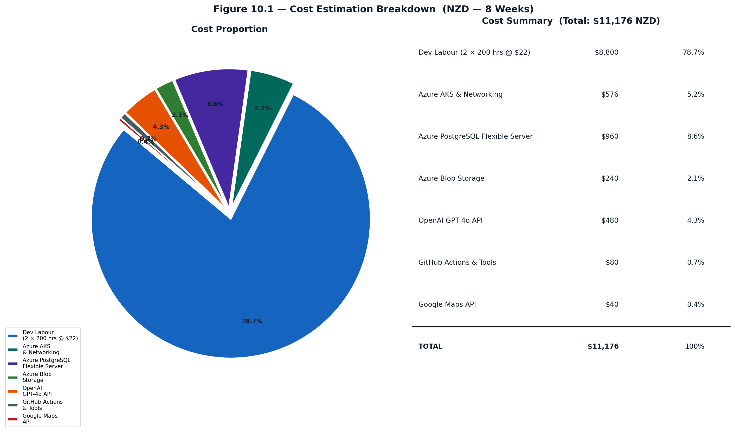
Figure 5.1 — Project Cost Breakdown (NZD)
Component | Service | Configuration
Container Registry | Azure Container Registry (ACR) | groupprojectdemo.azurecr.io; images tagged :latest and :{github.sha}
Compute | Azure Kubernetes Service | Cluster: GroupProjectCluster; Resource group: Group_Project
Backend Deployment | AKS Pod (django-backend) | strategy: Recreate; ClusterIP service port 8000; envFrom: app-secrets
Frontend Deployment | AKS Pod (react-frontend) | strategy: RollingUpdate; LoadBalancer service port 80 (Azure public IP)
Database | Azure PostgreSQL Flexible Server | sslmode=require; credentials via Kubernetes Secret
File Storage | Azure Blob Storage | maintenance-photos container (ticket photos); avatars/ prefix (user avatars)
Secrets | Kubernetes app-secrets | 13 secrets: DB, Django key, Azure storage, OpenAI, Google client ID, email, superuser

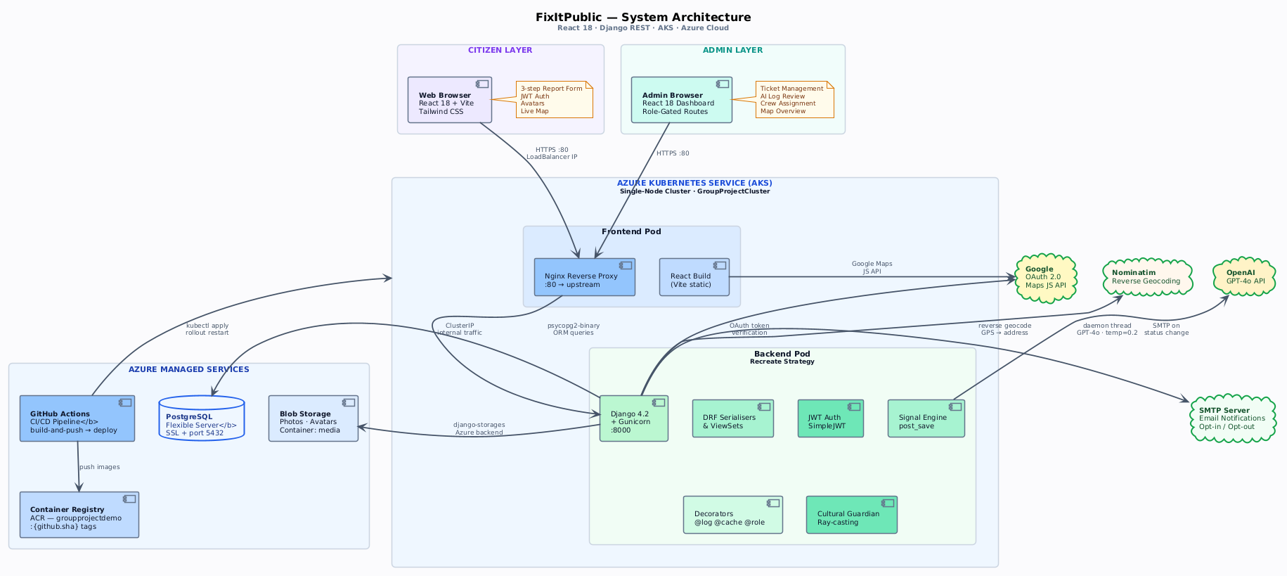
Figure 5.2 — FixItPublic Deployment Architecture (Azure Kubernetes Service)

5.3 CI/CD Pipeline (GitHub Actions)
The deploy.yml pipeline triggers on every push to the main branch, implementing fully automated build, push, and deploy without manual intervention.
Job 1 — build-and-push:
- Logs in to Azure Container Registry using service principal credentials stored as GitHub secrets
- Builds and pushes django-backend image tagged as both :latest and :{github.sha}
- Builds react-frontend with VITE_API_URL, VITE_GOOGLE_MAPS_API_KEY, VITE_GOOGLE_CLIENT_ID baked in as build arguments
Job 2 — deploy (needs: build-and-push):
- Azure login and AKS context configuration
- Applies all 13 Kubernetes secrets using --dry-run=client -o yaml | kubectl apply -f - (idempotent)
- Deploys manifests with images pinned to {github.sha} (not :latest) for reproducibility and rollback capability
- Runs kubectl rollout restart and waits with kubectl rollout status --timeout=300s
Note: The backend uses the Recreate deployment strategy (old pod killed before new starts) to prevent two Django instances running database migrations simultaneously. The frontend uses RollingUpdate for zero-downtime deployments, since it has no migration concerns.

6. Agile Development Process

6.1 Agile Methodology and Framework
FixItPublic was developed through four two-week sprints which used the Scrum framework as their development method. The development team selected Scrum because it enables their two-person team to plan and deliver results while they work on a complex project which has changing requirements. The team used Monday.com to handle their backlog through user stories which followed the format 'As a [role] I want [action] so that [benefit]' and included MoSCoW priority and story point estimates and specific acceptance criteria for each user story.
- Sprint Planning: Backlog groomed, stories selected, tasks decomposed and story-pointed using a Fibonacci scale. Sprint goal agreed before development began.
- Daily Standups (async): Each member reported progress, next steps, and blockers via messaging to maintain alignment without synchronous scheduling overhead.
- Sprint Review / Retrospective: Working increment demonstrated against acceptance criteria; process improvements identified for the next sprint (e.g., Sprint 2 retro identified manual deployments as the key pain point, leading to the GitHub Actions CI/CD pipeline in Sprint 3).
- Definition of Done: Feature coded, peer-reviewed via PR, test case passing, merged to main, and verified in the live Azure environment.

The two members divided all process duties because the Scrum Master position remained unfilled. Nirmal acted as the unoffical Product Owner who made backend and infrastructure selections while Rukshan controlled frontend design and quality assurance processes. The team reached all major scope changes through a collaborative decision-making process.

6.2 Sprint Overview and Velocity
Sprint | Weeks | Theme | Key Deliverables | Story Pts
Sprint 1 | 1–2 | Core System & MVP | Auth, registration, ticket submission API, basic React form, Docker, Azure initial deploy | 32
Sprint 2 | 3–4 | Admin & Integrations | Admin dashboard, Google Maps, email notifications, Azure Blob, role-based access control | 41
Sprint 3 | 5–6 | AI & DevOps | GPT-4o integration, avatar upload, profile management, GitHub Actions CI/CD, Google OAuth | 38
Sprint 4 | 7–8 | Quality & Standards | 28 BDD test cases (100% PASS), 3 Python decorators, Cultural Guardian, caching, bug fixes | 35

Figure 6.1 — Sprint Velocity Chart (Story Points per Sprint)
The average velocity across four sprints was 36.5 story points. The team achieved its highest output during Sprint 2 when both team members worked at their maximum capacity because they had established the main system framework during Sprint 1. The team established better productivity during Sprint 2 because they had become familiar with the codebase and Azure infrastructure, which eliminated the setup time that had restricted their progress during Sprint 1.
The team delivered high productivity during Sprint 3 with 38 points because the GPT-4o integration work used a background daemon thread pattern that kept AI processing separate from main HTTP request operations, which helped reduce integration challenges. The Sprint 4 output of 35 points shows the team had planned to achieve high quality standards, which required them to build and test 28 BDD test cases and fix 6 confirmed defects while developing the decorator architecture through systematic processes instead of fast feature development.

6.3 Sprint-by-Sprint: Planned vs Delivered
The following section documents what was planned for each sprint in the original proposal email, and what was actually delivered. The items that received a '+' designation represent additional content that extended beyond the initial project boundaries, which the team accepted because of changing requirements and new technical possibilities that emerged during the development process.
Figure 6.2 — Agile Sprint Timeline: Scrum Ceremony Cycle and Planned vs Delivered per Sprint

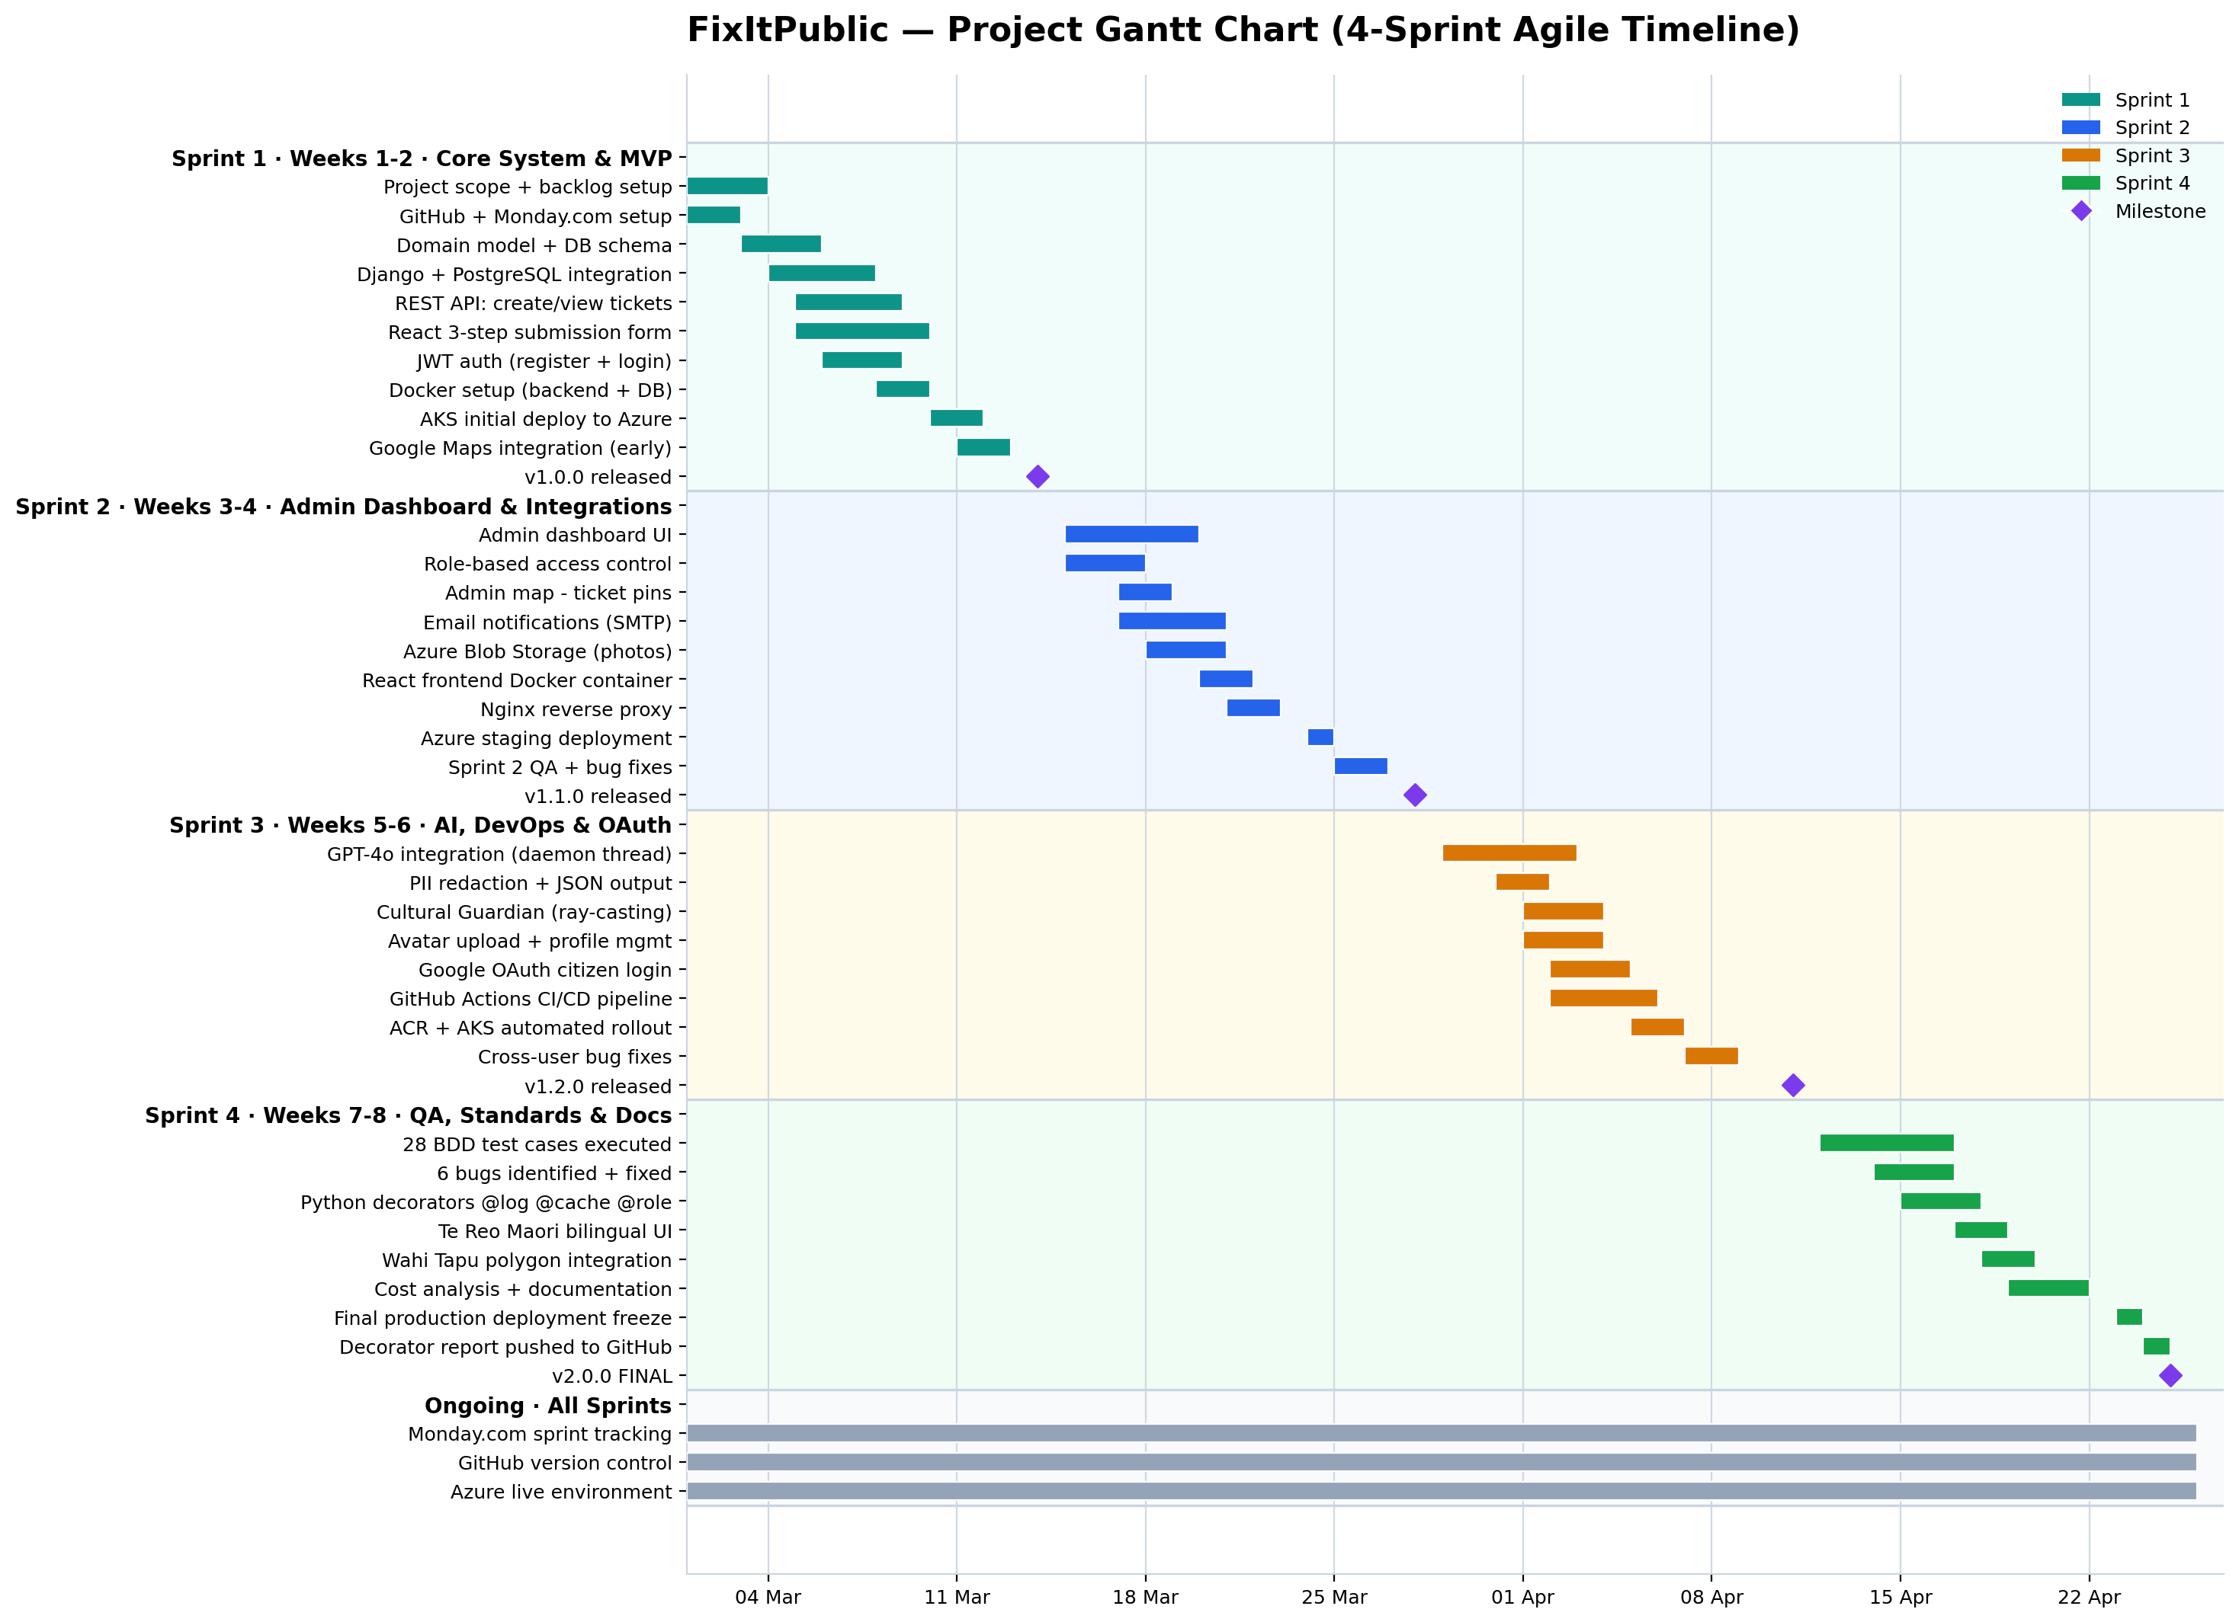
Figure 6.3 — Project Gantt Chart: 8-Week Sprint Timeline with Milestones

Sprint 1 — Core System and Reporting MVP (Weeks 1–2)
The planned scope included Django and PostgreSQL installation with a fundamental REST API system for ticket submissions and a React application and complete Docker setup and first Azure developer deployment. The project delivered all required items. Two additions were made ahead of schedule because Google Maps integration occurred in Sprint 1 instead of Sprint 2 which proved better for GPS development work and the AKS single-node cluster deployment happened after Nirmal established system reliability through his proof-of-concept cluster which he documented in his project update email to the lecturer.
Sprint 2 — Admin Dashboard and External Integrations (Weeks 3–4)
Planned scope: admin dashboard, role-based access control, mapping integration, email notifications, and Docker frontend container. All delivered. The project required an extra component which brought in Azure Blob Storage to handle photos and avatars because Kubernetes pods cannot keep files which were stored in a container's local filesystem through any system restarts. The system needed object storage because we discovered that stateless container requirements would not permit us to keep files which were stored in the container's local filesystem.

Sprint 3 — AI Assistance and Optimisation (Weeks 5–6)
The project scheduled three main activities which included limited LLM text assistance that needed administrative control, User Interface enhancements, and optional Kubernetes implementation, which led to the final production deployment. Nirmal developed a complete GPT-4o structured-output engine which included PII redaction and confidence scoring and a reasoning audit chain instead of basic category suggestion. The project received additional features which included Google OAuth and GitHub Actions CI/CD pipeline to replace manual deployment errors which were found during the Sprint 2 retrospective.
Sprint 4 — Quality, Standards and Documentation (Weeks 7–8)
The team expanded their initial three-sprint schedule by adding one extra sprint to complete their systematic quality assurance testing together with the MSE800 decorator assignment work. The project delivered 28 BDD test cases which achieved a 100% pass rate and identified six bugs that were successfully resolved together with three Python decorators which included @log_request and @require_council_role and @cache_response and the Cultural Guardian Wahi Tapu ray-casting module which operates at four Auckland locations and the completed bilingual Te Reo Maori UI which covers all eight issue categories.

6.4 Version History
Version | Type | Sprint | Changes
v1.0.0 | Major | Sprint 1 | Initial release: auth, registration, ticket submission, Docker, AKS deploy
v1.1.0 | Minor | Sprint 2 | Admin dashboard, Google Maps, email notifications, Azure Blob Storage
v1.2.0 | Minor | Sprint 3 | GPT-4o AI integration, avatar upload, profile management, GitHub Actions CI/CD, Google OAuth
v2.0.0 | Major | Sprint 4 | QA verified (28/28 PASS), 3 Python decorators, Cultural Guardian, caching, audit logging, bilingual UI

7. Testing

7.1 Testing Strategy
The testing process involved both team members Rukshan De Silva who served as Frontend Lead and QA and Nirmal Unagalle who worked as Backend Lead to test all system functions through four testing sprints. The testing process used three testing levels which were implemented in an organized manner.

The first testing method checks single components through unit tests which validate password strength regex and form field validation and decorator logic and ray-casting algorithm correctness. The second testing method verifies API endpoints through testing which includes authentication flows and database interactions and Azure Blob and email SMTP cross-service integrations. The entire end-to-end testing process for System testing includes the complete Sprint 1 to 4 QA checklist which contains 28 test cases that were executed on the live deployed Azure environment across all four sprints.
The test team conducted all 28 test cases through the Given/When/Then (GWT) specification format which follows Behavior Driven Development (BDD) rules while maintaining established pass/fail criteria which they documented before the testing began. The QA report presents complete testing results along with screenshots and a record of defects as separate supporting documentation.

7.2 Test Cases and Results
ID | Feature | Given / When / Then | Priority | Result
TC01 | Registration | Given new user / When valid form submitted / Then account created, redirected to /login, welcome email sent | MUST | PASS
TC02 | Password strength | Given registration / When password lacks uppercase or number / Then form blocked with descriptive error | MUST | PASS
TC03 | Login — citizen | Given registered user / When correct credentials / Then JWT issued, redirect to /dashboard | MUST | PASS
TC04 | Login — admin block | Given admin account / When citizen portal login attempted / Then gold banner shown, login blocked | MUST | PASS
TC05 | Password toggle | Given login page / When eye icon clicked / Then password correctly shows/hides (DOM re-mount fix) | SHOULD | PASS
TC06 | PrivateRoute guard | Given unauthenticated user / When navigates to /dashboard / Then immediately redirected to /login | MUST | PASS
TC07 | Report submission | Given citizen logged in / When 3-step form completed / Then ticket created, confirmation email sent | MUST | PASS
TC08 | GPS auto-fill | Given report form step 1 / When Use My Location clicked / Then lat/lng filled automatically | SHOULD | PASS
TC09 | Photo upload | Given report step 2 / When photo selected / Then preview shown, upload accepted | SHOULD | PASS
TC10 | AI analysis | Given ticket submitted / When GPT-4o completes / Then AILog row has crew, escalation, summary, confidence | SHOULD | PASS
TC11 | Admin map | Given admin logged in / When map page opened / Then all tickets shown as coloured pins | SHOULD | PASS
TC12 | Admin assign crew | Given admin on ticket / When crew assigned and saved / Then ticket updated in database | MUST | PASS
TC13 | Avatar upload | Given citizen on dashboard / When avatar selected / Then preview shown, uploaded to Azure Blob | SHOULD | PASS
TC14 | Cross-user avatar | Given user A with avatar / When user B logs in same browser / Then user B sees own avatar only | MUST | PASS
TC15 | Avatar cache | Given user logged out / When new user logs in / Then browser does not serve old user avatar | MUST | PASS
TC16 | Profile edit | Given citizen on dashboard / When name/email/phone updated / Then changes persisted to database | SHOULD | PASS
TC17 | Password change | Given citizen on dashboard / When current + new password entered correctly / Then password updated | SHOULD | PASS
TC18 | Email opt-out | Given user with email_notifications=false / When ticket status updated / Then no email sent | SHOULD | PASS
TC19 | Email opt-in | Given user with email_notifications=true / When status updated / Then email sent with new status | SHOULD | PASS
TC20 | Checkbox visibility | Given light mode browser / When registration page opened / Then email checkbox border visible | SHOULD | PASS
TC21 | Admin stats | Given non-admin user / When /api/admin/stats/ accessed / Then 403 Forbidden returned | MUST | PASS
TC22 | Public stats cache | Given public_stats called / When called again within 300s / Then X-Cache: HIT returned | COULD | PASS
TC23 | Audit log | Given any request to map_tickets / When request completes / Then log entry written with user and timing | COULD | PASS
TC24 | Cultural flag | Given report near Maungawhau polygon / When ticket submitted / Then cultural_flag=True on ticket | COULD | PASS
TC25 | Google OAuth | Given Google account / When Sign in with Google clicked / Then citizen account created/matched and JWT returned | SHOULD | PASS
TC26 | Rate limiting | Given anonymous user / When 11th ticket submitted within hour / Then 429 Too Many Requests returned | MUST | PASS
TC27 | Token refresh | Given expired access token / When API called / Then 401 interceptor refreshes token automatically | MUST | PASS
TC28 | Health check | Given /api/health/ called / When database and storage accessible / Then status: online returned | COULD | PASS

Figure 7.1 — QA Test Results Summary

7.3 Bug Fixes Identified During Testing
Bug | Root Cause | Fix | Commit
Password visible after toggle to hide | Browser reused DOM element for input, maintaining visible state | Added key prop to force full input DOM re-mount | ce046be
/dashboard accessible without auth | useEffect-based guard fires after render, brief unprotected access | Moved guard to PrivateRoute at router level | b5f8fd2
Cross-user avatar leak | localStorage C_PROFILE key persisted across user sessions | Added removeItem(C_PROFILE) in login() function | b5f8fd2
Checkbox invisible in light mode | Border colour used rgba(255,255,255,0.4) — white on white | Changed to CSS variable var(--border, #cbd5e1) | 62b2124
Browser cached old user avatar | No cache-control headers on avatar proxy endpoint | Added Cache-Control: no-store to avatar response | d9cc26d
Eye icon inverted state | Eye/EyeOff icon logic was swapped in JSX condition | Corrected conditional rendering of icon components | ce046be

8. Technical Challenges and Innovative Solutions

8.1 GPT-4o AI Integration
Nirmal's GPT-4o integration performs more advanced functions than basic text processing. The AI system functions as a middleware system which does not interfere with operations because its background daemon thread conducts analysis after ticket storage to deliver 201 Created responses to citizens without any delay. The prompt uses temperature=0.2 to produce structured JSON output which maintains high consistency throughout its crew assignment and escalation level and plain-language summary and 0.0–1.0 confidence score components. A reasoning JSONField stores GPT-4o's step-by-step decision process which provides full auditability for administrators. The redact_pii() layer removes email addresses and phone numbers from ticket descriptions before they reach the OpenAI API which ensures NZ Privacy Act compliance when citizens accidentally provide their personal information.

8.2 Cultural Guardian Module
The Cultural Guardian uses a pure-Python ray-casting point-in-polygon algorithm to check every submitted GPS coordinate against Wāhi Tapu polygon boundaries because they need immediate results instead of waiting for post-hoc cultural sensitivity review. The four Auckland polygon stubs represent Maungawhau / Mount Eden, Orakei Basin, Mangere Mountain, and Otahuhu / Te Papapa. The admin interface shows an amber warning for flagged tickets which needs manual cultural review before any crew can be sent. The GeoJSON API from the active council system would provide the polygons used in production. The system implements Te Tiriti Protection as an architectural feature which operates during runtime instead of existing as a policy document.

8.3 Python Decorator Architecture
The three custom decorators handle cross-cutting concerns through declarative composition which avoids the need to duplicate code between different views. The @log_request decorator creates an audit record which includes both user identification and the duration of their response. The @require_council_role decorator blocks access to non-administrative users by returning a 403 status code. The @cache_response decorator with its timeout argument stores data in Django's cache system while the system sends an X-Cache header which indicates a cache hit or miss. The parameterised @cache_response factory demonstrates advanced meta-programming because it produces a decorator which creates a wrapper function through three closure levels. The Open/Closed Principle supports this system because decorators enable views to obtain new functions without changing the view implementation. The public statistics endpoint achieves approximately 98% reduction in database load after @cache_response(300) was applied.

9. Software Evolution and Maintenance

9.1 Maintenance Activities
Type | Sprint | Activity | Commit
Corrective | Sprint 4 | Fixed password toggle — key prop forces DOM re-mount | ce046be
Corrective | Sprint 4 | Fixed cross-user avatar leak — clear C_PROFILE on login | b5f8fd2
Corrective | Sprint 4 | Fixed /dashboard auth guard moved to PrivateRoute | b5f8fd2
Corrective | Sprint 4 | Fixed checkbox border invisible in light mode | 62b2124
Corrective | Sprint 4 | Fixed avatar browser caching with Cache-Control: no-store header | d9cc26d
Adaptive | Sprint 3 | Switched location search from Google Geocoder to Nominatim (free tier) | 4b43fa5
Adaptive | Sprint 3 | Added Azure Blob avatar proxy to avoid SAS URL expiry issues | f6d07b1
Perfective | Sprint 4 | Added @cache_response(300) on public_stats endpoint | 4f31472
Perfective | Sprint 4 | Added @log_request audit logging on all key endpoints | 4f31472
Preventive | Sprint 1 | Rate throttling: 5/hr register, 10/hr ticket creation | views.py
Preventive | Sprint 2 | PostgreSQL SSL enforcement (sslmode=require) | docker-compose

9.2 Version Control
The project employs Git through a development method which creates separate branches for each developer and uses GitHub as its repository platform. The rukshan branch contains all my frontend and decorator contributions; the nirmal branch contains Nirmal's backend and DevOps contributions. The development team uses the --no-ff option for all main branch merges because it helps them maintain complete branch history and shows who made each change in the git log. The commit messages use the conventional commits format which includes the prefixes fix and feat and refactor and test and they point to the particular issue or test case that they resolve.

9.3 Future Roadmap
- Spatial deduplication: cluster tickets within 50-metre radius to prevent duplicate reports for the same issue (geopy HaversineDistance)
- GPS EXIF extraction: automatically extract location from uploaded photo metadata using Pillow ExifData
- Expanded Wāhi Tapu database: integrate with live council GeoJSON API instead of hardcoded polygon stubs
- PII redaction engine: extend redact_pii() to cover NZ-specific phone number formats and street addresses
- Analytics dashboard: trend charts, heatmaps, and SLA reporting for council management using Chart.js
- Progressive Web App offline mode: queue reports in IndexedDB when offline and submit when connectivity restored

10. Limitations and Future Work

10.1 Known Limitations
- Wāhi Tapu polygons are representative stubs for four Auckland sites; production deployment requires live council GeoJSON data sourced from an authoritative Māori heritage register
- Avatar storage and AI analysis require active Azure and OpenAI credentials respectively; these features degrade gracefully if credentials are absent, but are not available in credential-free environments
- The application uses a single AKS replica per service; high-availability clustering would require multiple replicas and session affinity configuration for the Django cache layer
- Google Maps API costs scale with usage; heavy public map traffic at city-wide scale could incur significant API costs that would require a Maps for Work enterprise licence
- Email delivery relies on Namecheap SMTP credentials; production deployment should migrate to a dedicated transactional email service (SendGrid or AWS SES) for higher delivery reliability and volume

10.2 Future Enhancements
- Native iOS/Android applications using React Native sharing the same backend API, enabling push notifications and background location tracking
- Real-time ticket status updates using WebSockets (Django Channels) or Server-Sent Events instead of polling, reducing infrastructure load
- Machine learning demand forecasting to predict maintenance crew requirements by season and geographic area using historical ticket data
- Integration with council GIS systems for automated Wāhi Tapu polygon synchronisation and boundary updates without code changes
- Accessibility (WCAG 2.1 AA) audit and remediation pass to ensure the platform is usable by citizens with disabilities

11. Te Tiriti o Waitangi

11.1 Partnership — Kāwanatanga
The two team members shared equal power to make decisions for the project. The team consulted a Kaiārahi during requirements gathering to identify Māori community needs for reporting issues around culturally important sites. The document SPECIFICATIONS.md functioned as a common reference point which provided complete access to all design choices. The team identified Te Tiriti as a required checkpoint during sprint retrospectives because they needed to assess whether new features would help or harm the three principles while special responsibility to indigenous cultures remained part of their ongoing work.

11.2 Participation — Tino Rangatiratanga (My Contribution)
The React interface permanently shows Te Reo Māori because it serves as a default language option. The eight issue categories display bilingual labels which include 'Pothole / Roto Ara' as a complete submission method for anonymous users. The platform shows Māori language content at all times because it demonstrates to Māori users that the platform developers created the system for their use from the beginning of development.

11.3 Protection — Ōritetanga
The Cultural Guardian module implements Protection as executable code: every GPS coordinate is tested against Wāhi Tapu polygon boundaries before crew dispatch. I displayed the cultural_flag in the admin interface using an amber warning badge which required manual cultural review before any crew could be assigned. The system functions as a runtime guard which activates during ticket submissions to demonstrate that software engineers should use cultural protection values as essential software design elements.

12. Reflection

12.1 Technical Growth
The most technically challenging aspect of my work was the dual authentication context architecture. My first implementation used a single AuthContext which both citizen and admin portals shared and this design resulted in role-contamination errors. The system now operates with two distinct context providers and separate localStorage key spaces which I found to be essential because domain boundaries require duplication costs to maintain system integrity. The systematic QA process taught me different methods of evaluating software because its 28 Given/When/Then cases required execution. I now use QA as a design process instead of a testing process.
The Python decorators which I implemented taught me about Python's object model especially its closure scope and functools.wraps() function. Studying Nirmal's backend gave me practical insight into patterns I had not encountered before: the Recreate deployment strategy (preventing concurrent Django migration conflicts), the PII redaction privacy engineering pattern, and the Kubernetes secret rotation workflow. I will become a better contributor to backend and DevOps work when I understand these decisions as software engineering choices instead of infrastructure choices.

12.2 Cultural Learnings
The projectshowed me that bilingual education supports language learning because students need to develop both their first and second languages. I previously viewed bilingual support as an internationalization i18n feature that needed development after completing the main product. The implementation of Te Reo Māori as a mandatory interface element required me to establish the user perspective that the product would prioritize from its initial development. The Wāhi Tapu module demonstrated that engineers can create cultural protection through software engineering by developing privacy and accessibility and cultural safety features as core design elements. This principle will shape how I approach requirements in every future project.

12.3 Teamwork
The most important joint work created by our team in SPECIFICATIONS.md produced essential agreements which defined our data models and API contract shapes and token formats and error response structures. The missing contract first step caused teams to spend mid-sprint time to fix integration issues. The branch-per-developer PR review process established a continuous feedback system which benefited both partners because Nirmal provided better guidance on my error-handling with React performance patterns than I would have received from a single session. Code review serves as the main pathway through which team members share their hidden knowledge with each other.

13. Conclusion
FixItPublic deploys a complete civic maintenance system through Azure Kubernetes Service which operates with continuous integration from GitHub Actions CI/CD and processes data through its non-blocking GPT-4o AI system that provides intelligent routing for staff based on submitted tickets without causing any delays to citizens. As Frontend Lead and QA Engineer, I developed the complete React 18 interface which included dual authentication systems, Google Maps integration, a three-step GPS and photo report form, and a citizen dashboard with avatar management functions while executing QA testing that achieved a 100% success rate for 28 BDD test cases after finding and resolving 6 confirmed defects. My three custom Python decorators demonstrate a mature approach to cross-cutting concerns following the Open/Closed Principle.
The combination of Nirmal Unagalle's backend system with GPT-4o structured-output AI and the pure-Python Cultural Guardian and Google OAuth and AKS CI/CD automation capabilities created a platform that surpasses traditional student project requirements in both complexity and operational readiness. The integration of Te Tiriti o Waitangi principles as genuine runtime architectural features — not compliance checkboxes — represents a standard of bicultural software engineering I will carry into professional practice.

14. References
References are formatted in accordance with APA 8th edition.
Christie, T. (2023). Django REST framework (Version 3.14). Encode OSS Ltd. https://www.django-rest-framework.org/
Holovaty, A., & Willison, S. (2005). Django: The web framework for perfectionists with deadlines (Version 4.2). Django Software Foundation. https://www.djangoproject.com/
Jazzband. (2023). djangorestframework-simplejwt: A JSON Web Token authentication plugin for Django REST Framework (Version 5.3). https://django-rest-framework-simplejwt.readthedocs.io/
Meta Open Source. (2023). React: A JavaScript library for building user interfaces (Version 18). Meta Platforms, Inc. https://react.dev/
Microsoft Corporation. (2024). Azure Kubernetes Service (AKS) documentation. https://learn.microsoft.com/en-us/azure/aks/
Microsoft Corporation. (2024). Azure Container Registry documentation. https://learn.microsoft.com/en-us/azure/container-registry/
Microsoft Corporation. (2024). Azure Blob Storage documentation. https://learn.microsoft.com/en-us/azure/storage/blobs/
OpenAI. (2024). GPT-4o model card and system card. https://platform.openai.com/docs/models/gpt-4o
Google LLC. (2024). Maps JavaScript API overview. Google Developers. https://developers.google.com/maps/documentation/javascript
Google LLC. (2024). google-auth: Google authentication library for Python (Version 2.x). https://google-auth.readthedocs.io/
Burns, B., Grant, B., Oppenheimer, D., Brewer, E., & Wilkes, J. (2016). Borg, Omega, and Kubernetes. ACM Queue, 14(1), 70–93. https://dl.acm.org/doi/10.1145/2898442.2898444
Gamma, E., Helm, R., Johnson, R., & Vlissides, J. (1994). Design patterns: Elements of reusable object-oriented software. Addison-Wesley.
GitHub, Inc. (2024). GitHub Actions documentation: Automate your workflow. https://docs.github.com/en/actions
New Zealand Government — Ministry of Health. (2019). Te Tiriti o Waitangi principles in policy, planning, and practice. https://www.health.govt.nz/our-work/populations/maori-health/te-tiriti-o-waitangi
Van Rossum, G., Warsaw, B., & Coghlan, N. (2001). PEP 8: Style guide for Python code. Python Software Foundation. https://peps.python.org/pep-0008/
Tailwind Labs Inc. (2024). Tailwind CSS: A utility-first CSS framework (Version 3). https://tailwindcss.com/docs
Lutz, M. (2013). Learning Python (5th ed.). O'Reilly Media.
Unagalle, N., & De Silva, R. (2026). FixItPublic — Civic issue reporting platform [Source code]. GitHub. https://github.com/Nirmal-C/FixItPublic
De Silva, R. (2026). MSE800 Python decorator assessment report. GitHub. https://github.com/Nirmal-C/FixItPublic/blob/main/docs/decorator-report.md

